**Website Structure for – RPN Stafflink Service Provider Pvt. Ltd.**

**Header / Navigation:**

Logo + Company Name | Home | About Us | Services | Job Seeker | Clients | Contact

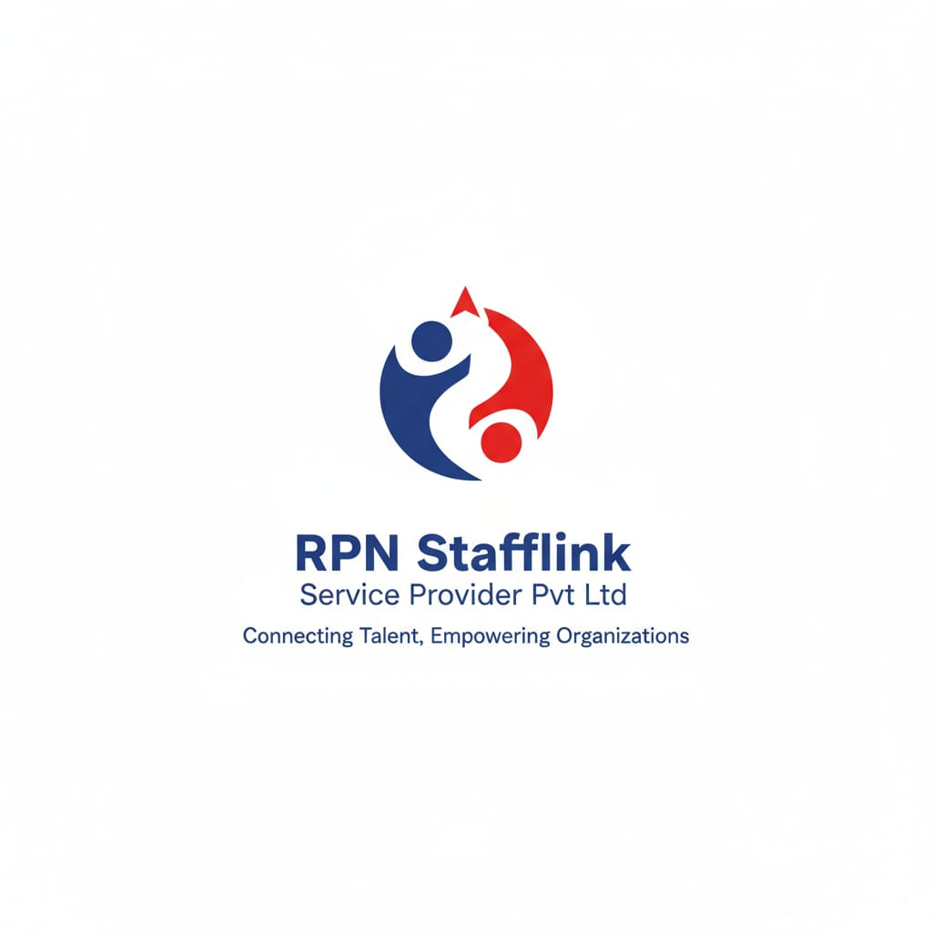

**Hero Section**

**Heading [Tagline]**

*“Reliable Manpower Solution for your business growth”*

Sub-Headline – We provide Skilled and non skilled staff to corporate offices, private firms, supermarkets, Hospitals, Education and Govt. Organizations across all over India, Our Head office located at Nagpur Maharashtra.

**Call to Action Buttons (CTA):**

Get Staff Now

Partner with Us

**Enquiry Here**

Background Idea – Corporate office environment photo.

Transparent overlay with tagline.

Professional these (blue/white/gray tones for trust and reliability)

**About Us**

**Who We Are**

RPN Stafflink Service Provider Pvt. Ltd. is a trusted manpower outsourcing company, providing reliable and trained staff for corporate offices, institutions, hospitals, and industries. With a strong focus on quality, discipline, and professionalism, we ensure that our clients receive the right workforce to meet their business needs.

**Our Presence**

We operate with a strong regional presence across India, head office located at Nagpur MH, India. This structure allows us to deliver efficient, localized services while maintaining the professionalism of a unified private limited company.

**Our Mission**

To provide **dependable, cost-effective, and skilled manpower solutions** that help our clients focus on their core business while we take care of staffing needs.

**Our Vision**

To be recognized as a **leading manpower provider in all over India**, known for our transparency, efficiency, and client-focused approach.

**Our Values**

* **Reliability** – Always delivering on our commitments
* **Professionalism** – Trained, uniformed, and background-verified staff
* **Client First** – Customized solutions as per business requirements
* **Compliance** – 100% legal and statutory adherence

**Why Choose Us?**

* Verified and trained staff across multiple industries
* Quick replacement guarantee when required
* Dedicated partner-led management in every state
* Strong focus on compliance, safety, and punctuality

**Services**

1. Manpower Supply
2. Staffing & Payroll solutions
3. Education Staffing
4. Recruitment & Consultancy

**Main Objective Clause**

1. **To carry on the business of providing** skilled, semi-skilled, and unskilled manpower and staffing solutions to retail chains, supermarkets, hypermarkets, warehouses, online delivery platforms, and similar service industries, and to supply and manage manpower for entities such as D-Mart, V-Mart, Instamart, and other allied organizations, for their operational, administrative, logistics, and customer service, and other related requirements, etc.
2. **To undertake the management and support** of educational institutions, including schools, colleges, universities, and coaching centers, by providing qualified teaching and non-teaching staff, administrative assistance, and training services for students, thereby facilitating academic excellence and ensuring smooth institutional functioning.
3. **To provide consultancy, recruitment, and outsourcing services** related to manpower supply, training, career development, and other allied activities for the retail, service, and educational sectors, and to carry on any other lawful activity incidental or ancillary to the attainment of the above objects, etc.

**Clients**

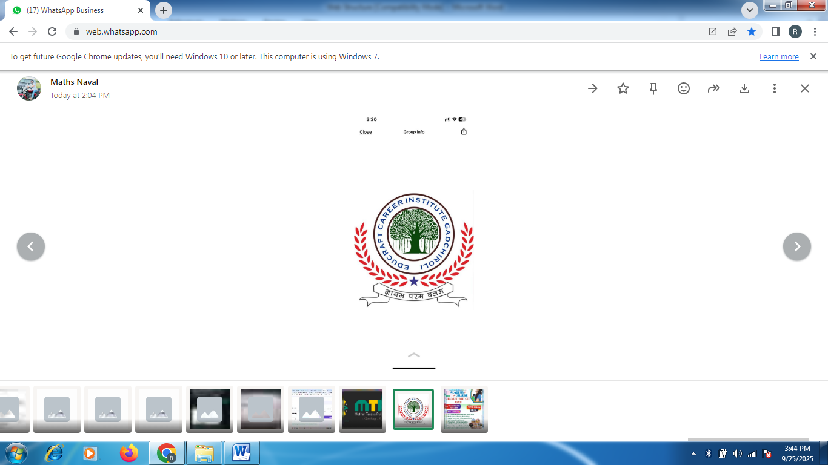 **Educations**

 

  

**Hospitals**

  

**TCS –**



**Electrical**



**Contact –** 9923404722 | 7066019483 | 8894623825 | 7020348147

**Address –** Uday nagar Nagpur MH

**E-mail–** [rpnstafflinkserviceprovider@gmail.com](mailto:rpnstafflinkserviceprovider@gmail.com)

**Footer –** Quick links; Social Media Handles; Copyright Information